9.3: a) 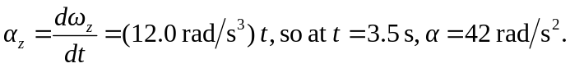The angular acceleration is proportional to the time, so the average angular acceleration between any two times is the arithmetic average of the angular accelerations. b) 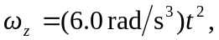 so at 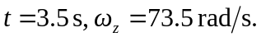 The angular velocity is not linear function of time, so the average angular velocity is not the arithmetic average or the angular velocity at the midpoint of the interval.

